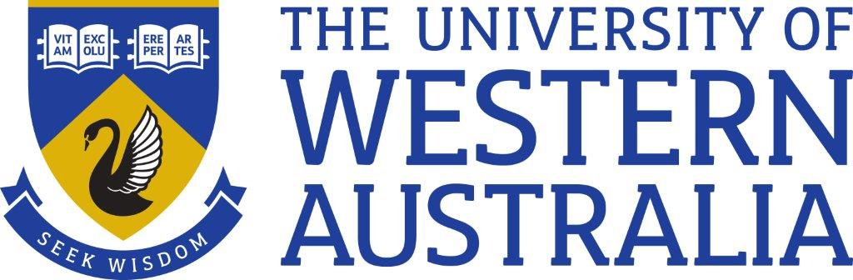
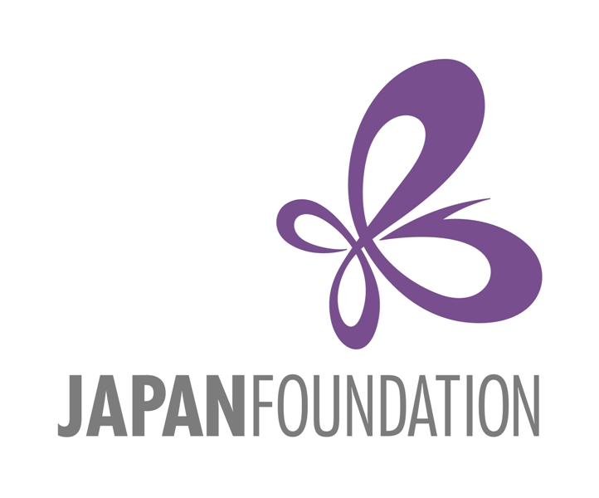

WA Japanese Language Speech Contest 2023

Saturday, 26th August, 2023
University of Western Australia

The aim of the WA Senior School Japanese Language Speech Contest 2023 is to encourage students of Japanese to showcase their language skills in a challenging environment. Winners from the High School and Open Divisions will progress to the Australian final.

The 2023 competition is sponsored by the Japan Foundation, Sydney, and supported by Consulate-General of Japan in Perth, Australia Japan Society of WA and Japanese Language Teachers’ Association of WA.

Participants are required to submit an English summary of their speech with their application form and a copy of their full speech in Japanese and English one week prior to the contest (18th August 2023).

The WA competition has two categories:

- High School Senior Division
- Open Division

Up to two students per school per category will be accepted in the High School Senior Division.

Judging criteria will follow the Japan Foundation National Guidelines.
Please read the Contest Guide carefully. Teachers and applicants must familiarise themselves with the rules and advice in the document available at:
https://jpf.org.au/jpf/jpfmedia/%E2%98%852023-Contest-Guidelines.pdf

All contestants will receive a participation certificate. Prizes will also be awarded in each division.

1st Prize: $150 voucher
2nd Prize: $100 voucher
3rd Prize: $50 voucher

Judges will be from the field of Japanese language education and members of the
Japanese community and will decide the winners. The judges’ decision is final and no correspondence will be entered into. The content of the judges’ discussion is not open to the public at any time.

WA Japanese Language Speech Contest 2023 – Guidelines

Subject of Speech:
The subject, content and form of the speeches are left open to each contestant. Entrants who have competed in previous contests may not use the same speech (this includes title and content) presented in previous years.
Length of Speech (Time Limit):
High School Senior Division: | 2.5 - 3 minutes
Open Division: | 4.5 - 5 minutes

Criteria for Speech:
- The speech must be the original work of the contestant. The degree of assistance given by teachers or by Japanese native speakers should be limited to no more than correcting grammatical errors or making minor alterations for the sake of continuity.
- Props (e.g. puppets, objects etc.) must not be used.
- Microphone with a stand will be provided for contestants.
- Contestants should not read their speeches. Contestants may refer to their notes, however, excessive consultation will result in marks being deducted
- Uniform is not necessary, however neat presentation is encouraged.
- Please be mindful of the speech time limit.
Q&A:

The Q&A has been eliminated from the marking criteria and will not be carried out in the finals. However, after delivering their speech, contestants may be asked up to four questions in Japanese but not necessarily based on their speech.

JUDGING CRITERIA & JUDGES:

The marking system is as follows for both High School and Open Divisions:

Content 50% (structure development, originality and uniqueness, message impact, justification and engagement)
Language 30% (grammar and expression, language variety, pronunciation and intonation)
Presentation 20% (delivery, memorisation and fluency)

